USB MCU CH554 evaluation board description
Version: 1.0
http://wch.cn
Translated by Blinkinlabs

1. evaluation version of the hardware icon

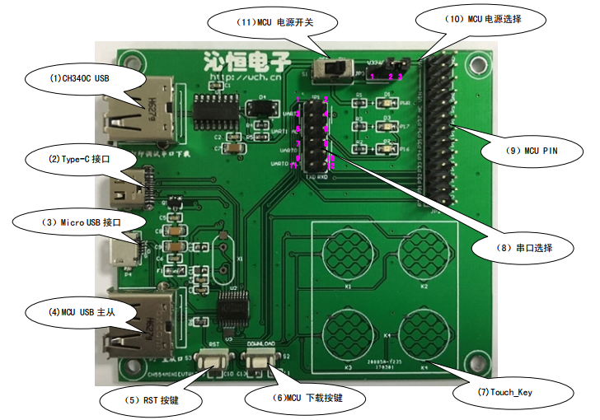
Note:
(8) Select the MCU serial port 0/1 and CH340C connected: In order to solve the case of some computers without serial port MCU serial port connected to the computer inconvenient circumstances. The use of USB to serial chip CH340C, MCU serial port 0 or 1 can be upgraded to USB and connected to the computer. Only one set of connections in the table below can be selected at a time.

 | Place jumper on pins | Other pins
Serial port 0 (P30, P31) | 9-7;10-8 | Disconnect
Serial port 0 mapping (P12, P13) | 9-11;10-12 | Disconnect
Serial port 1 (P16, P17) | 3-5;4-6 | Disconnect
Serial port 1 mapping (P32, P34) | 3-1;4-2 | Disconnect

(10) MCU power supply options: short circuit when 3.3V power supply 1-2, short circuit 2-3 when 5V power supply.

Evaluation board main chip CH554, supports up to 32MHz system clock speed, built-in 16K program memory ROM and 256 bytes of internal iRAM and 1K bytes on-chip xRAM, xRAM support DMA direct memory access.
CH554 built-in ADC analog-digital conversion, touch-button capacitance detection, 3 sets of timer and signal capture and PWM, dual asynchronous serial port, SPI and other functional modules, support USB-Host host mode and USB-Device device mode.
This evaluation board can achieve the above CH554 resources development and testing.

2. Evaluation kit Software Package description:
Source: www.wch.cn Search CH554
- File Name: CH554EVT.ZIP
Data package:
- Header file (C, assembly)
- Evaluation Board Schematic
- PCB diagram
- Software Library / Demonstrations

2.1 CH554.uvproj: CH554 keil4 project file

2.2 Public folder
- CH554 C language and assembly header
- SFR definition
- UART0 & 1 initialization
- delay function
- UART0 & 1 data transceiver function
- watchdog initialization

2.3 ADC folder
- ADC interrupt mode and query mode acquisition
- ADC sampling clock setting
- Voltage comparison function definition

2.4 DataFlash folder
- DataFlash byte read and write

2.5 GPIO folder
- GPIO settings
- GPIO interrupt instructions

2.6 IAP folder
- CH554 user program jump to BOOT upgrade demo

2.7 PWM folder
- PWM initialization
- PWM duty cycle setting function

2.8 SPI folder
- SPI master slave mode initialization and data transceiver demo
- master operation CH376
- slave connection to other C51 MCU

2.9 Timer folder
- Timer 0, 1, 2 initialization and timer
- counter function definition
- timer 2 capture function definition

2.10 Type-C folder
Type-C Master-Slave mode use example:
- Demonstrates the detection of Type-C positive and negative plug-in and power supply capability notification in master mode, slave mode, get DPF power supply capacity

2.11 TouchKey folder
- TouchKey function is enabled
- interrupt or query mode to collect key state

2.12 USB folder
USB related application example
- A. DEVICE folder
  - Analog USB mouse and keyboard routines to support part of the class command;
  - Analog manufacturers custom equipment, you need to install CH372 driver, you can debug 372test.exe (bulk data transceiver, in/out transmission);
  - Analog HID compatible device, support interrupt upload and download;
- B. HOST folder
  - USB host application examples, initialize and enumerate the USB port connected device, supports a level of external HUB, you can operate the USB mouse and keyboard
  - And HUB, printers, including HID class command processing;
- C. U_DISK
  - Read and write files in bytes, including file creation, deletion, modification of file attributes, modification of file names;
  - Enumerate the root directory or specify the current file;

2.13 USB_LIB folder
Configure the device command interface in USB File System Library and Host mode

2.14 PCB evaluation board information
- CH554 L and E package PCB
- schematic diagram

2.15 PUB Evaluation Board Description
- Evaluation Board Description
- Evaluation Board Schematic

3. MCU ISP download software description:

3.1 Download preparation

3.1.1 USB download
- The (10) jumper in Figure 1.1 selects the 5V supply (2-3);
- Hold down the (6) Download button in Figure 1.1;
- Connect (3) or (4) to the PC;
- release (6);
- Use ISP software download, specific reference 3.3 (1);

3.1.2 Serial Download
- The (10) jumper (2-3) in Figure 1.1 selects 5V for power supply;
- Hold down while powering on (6) Download button or not;
- Serial Port Download Use the P16 (RXD) and P17 (TXD) pins of the chip to select UART 1 in Figure 1.1 (8)

  - Key download: Press and hold down the (6) Download key in Figure 1.1 to release the key by (1) connecting the PC;
  - without key download: ISP tool click to download, and then by (1) connect the PC, release the button;
- Use ISP software to download, refer to 3.3 (1);

Software: Need to install WCHISPToolISP tool, USB driver is included in the installation package, the device is automatically installed after power-on.
Download link: http://wch.cn/download/WCHISPTool_Setup_exe.html

3.2 ISP software function description
WCHISPToolISP software main function:
- Through the USB interface to CH554 single download or more than one batch download or check;
- Serial port on a single download CH554 or specified interval time one by one download verification;
- EEPROM read and write;
- Support HEX or BIN format download;
- Support the initial settings of the interface to save and import files;
- Support download statistics show that the operation record is saved to the specified file;
- USB download mode, support equipment dynamic plug;
[figure omitted]

3.3 Software instructions:
- USB mode to download MCU program:
  - Select chip series: Click the "8-bit CH55X series" tab page;
  - Select Chip Type: Select "CH554" in "Chip Type" list;
  - Choose Download Method: Select "USB Download" in the "Download Method" list;
  - download configuration: in the "download configuration" column, set the download configuration;
  - Select Download Device: You can select the specified device from "USB Device List"
If the device is connected to the PC, the software will detect it and the following picture will appear: "USB List" shows "Model CH554 ...... Device No.1";
If no device is detected, check if (10) is connected to 5V, if USB is connected, and so on;
[figure omitted]
  - Select Download File: If IAP is not enabled in download configuration, just select the corresponding download file for "User Program File"
If you enable IAP, you need to select the corresponding download file for "IAP Program File" and "User Program File"
  - Single Download: Click "Download (D)" button to download a single device
Batch Download: If the download type is "USB Download", click the "Batch Download (B)" button to download multiple devices at the same time;
If the download type is "serial port download", click the "batch download (B)" button, according to "serial port batch download interval", as shown in Figure 3.5;
To detect the access to the device automatically download, until the "stop (S)" button to end batch download;
  - If "Download program automatically runs after download" is selected, the MCU will exit the download mode after downloading and load and run the user program automatically. If it is not selected, you will need to manually reset or re-power the hardware and load Run the user program.
  - When the download is finished, the software will show the current download status in the "Download Record" column, as shown in Figure 3.3;
[figure omitted]
- Serial download MCU program:
  - Select chip series: Click the "8-bit CH55X series" tab page;
  - Select Chip Type: Select "CH554" in "Chip Type" list;
  - Select the download method: in the "download method" list, select "serial download";
  - download configuration: in the "download configuration" column, set the download configuration;
  - Select Download Device: You can select the serial port number connected to the evaluation board in Serial Device List:
[figure omitted]
  - Select Download File: If IAP is not enabled, just select the corresponding download file for "User Program File"; if IAP is enabled, select the corresponding download file for "IAP Program File" and "User Program File"
  - Single Download: Click the "Download (D)" button to download a single device
Batch download: If download type is "serial download", click "batch download (B)" button and download will be detected automatically according to serial port serial download interval time until the click of "stop (S)" button Batch download;
Test equipment insertion interval,
[figure omitted]
  - If "Run the program automatically after downloading" is selected, the MCU will exit the download mode and load the running user program automatically. If it is not selected, you need to manually load the running user program after the hardware is powered on again.
  - After downloading, the software will show the current download status in the "Download Record" column, the download is successful as shown in Figure 3.6;
[figure omitted]
- MCU program verification:
  - Execute ISP downloading steps a, b, c, d, e, f;
  - Click on the title bar icon [figure omitted] or menu bar "function" -> "check" button MCU burn code and the specified "user program file" for comparison, "download configuration" and MCU programming Configuration comparison.
- MCU built-in EEPROM read and write
  - Perform ISP download steps a, b
  - Click the icon [figure omitted], in the pop-up "DataFlash" window EEPROM read and write and save operation.

4. KEIL project setup
[section omitted- we don’t have the IDE!]

